89.05.00c
To the Gardeners' Chronicle

[Our supplementary illustration represents the base of a tree stem, standing as it grew, turned into a dwelling by a Colonial squatter. The photograph, from which the figure was prepared, was kindly furnished by Baron Ferdinand von Mueller, Melbourne, and was taken by Mr. N. T. Caire of the same city.]

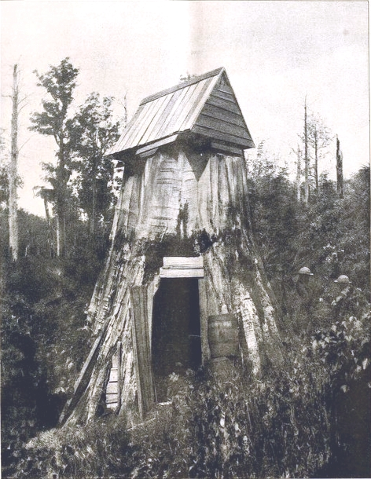

Letter not found. The text given here is from 'Eucalyptus amygdalina', Gardeners' chronicle, 6 July 1889, p. 14. The letter is dated to May as the latest likely date that it could have been sent to have been reported in this issue.
89-05-00c_image01.jpg. The full-page image is captioned 'Giant Gum Tree (Eucalyptus amygdalina) used as a dwelling in Gippsland, Victoria' and has the production details '"Ink photo", Sprague & Co. 22, Martins Lane, Cannon St, London, E. C.' (Supplement to Gardeners' chronicle, 6 July 1889).
N. J. Caire.
The article also reported that 'in a letter of Mr. J. Rollo's, of Balnarring, forwarded by Baron von Mueller, it is stated by the writer that in the Yarragon district he has measured trees which were from 330 to 340 feet in height, and in a valley of the southern range of mountains where the trees acquire even greater size, one was measured which reached the enormous height of 410 feet. Blue Gums (Eucalyptus globulus), grow to 300 feet in height in the same neighbourhood'. The information from Rollo was also used in M to the Editor of the Argus, 23 May 1889 (B89.05.01).

